
CSI: Colours in ink Key stage 2 Lesson Planning

Scheme of work unit: Solids, liquids and how they can be separated

National Curriculum link

Knowledge, skills and understanding Sc3 Materials and their properties

Separating mixtures of materials
Pupils should be taught:
- that some solids dissolve in water to give solutions but some do not (Opportunity to discuss what would happen if ink was added to water)
- how to separate insoluble solids from liquids by filtering (Opportunity to discuss why it is not possible to use filtering to separate the ink from water)
- how to recover dissolved solids by evaporating the liquid from the solution
- to use knowledge of solids, liquids and gases to decide how mixtures might be separated.

Learning outcome:

Decide who could have committed the crime using the results of the investigation (separate out the colours in ink using chromatography).

Introduction notes:

- Chromatography is the collective term for a family of laboratory techniques for the separation of mixtures.
- Paper chromatography is an analytical technique for separating and identifying mixtures that are or can be coloured, especially pigments.
- The technique is based on a small concentrated spot of the sample being applied to a piece of chromatography paper about 1cm from the base.
- The paper is then dipped into a suitable solvent, such as ethanol or water.
- The solvent moves up the paper by capillary action. As the solvent rises through the paper it meets and dissolves the sample mixture, which will then travel up the paper with the solvent.
- Different compounds in the sample mixture travel at different rates due to the difference in solubility in the solvent, and are thus separated out on the paper.

Information:
- Washable pens are used in this activity because the pigments in the inks are soluble in water.
- Inks may appear to be a single colour, but are often composed of differently coloured pigments. Water can dissolve these pigments to effect a separation and produce a decorative pattern.
- The filter paper acts as a stationary phase on which the separation takes place, whereas the water acts as a mobile phase to carry the pigments through the filter paper.
- Although colours of different manufacturers may appear to be the same, often different pigments and different ratios of pigments are used to produce the same colour. Thus, it is possible to tell what type of pen was used.

Lesson Plan:

Starter
Add a few drops of ink to water. Discuss with the class what happens to the ink. Opportunity to reinforce key words (soluble/insoluble/dissolve/mixture). Could discuss how the ink could be separated from the water again.

Main Activity
Students use chromatography to separate the colours in the ink of two different pens and compare these to the pen used by the thief in order to identify who committed the offence.

Worksheet available with instructions and questions.

Plenary
Discuss answers to question 4 and what CSI teams have to consider to convict suspects (what other evidence could be used).

Discuss what is required in the experiment to make it work. Could we do the same experiment to separate the colours in nail varnish? (No, as nail varnish is not soluble/yes, but would have to use acetone or other nail varnish remover instead of water)

Discuss other uses of chromatography (examples of use of chromatography: used to see if a blood sample contains drugs/used to identify the amount of pollutant in a water sample)

Resources required:

- 3 sample containers
Containers should ideally be long and thin – we have successfully used sample vials.
- Plastic pipettes (optional: used to add small volume of water)
- Filter paper (Blotting paper can be used)
- Scissors and a pencil
- Water
- A Ransom note (labelled as Evidence No: 080)
- 2 different black pens (labelled as Evidence No: 081 & 082)
- Envelopes with the address “George Bloggs, 4 Anystreet, Anytown”, written on them using one of the pens. This is illustrated on the top of the next page.

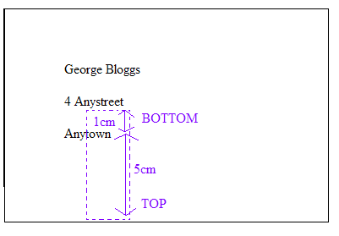
The area to be cut from the envelope needs to be of similar size to the filter paper.

The ink should be about 1cm from the bottom of the rectangular piece of paper and there should be plenty of paper above for the ink to travel up.

Labelling the top and bottom in pencil should avoid confusion.
Health and safety

Care must be taken if glassware is used.

Further Work

A similar practical investigate the colours in food dyes using chromatography.
Link to other separation techniques, such as separating out the pigments in leaves

Answers for worksheet:

1-3 As observed/depending on pens used
4. No. Pens are pretty common and so it is not definite that they committed the crime.

CSI: Colours in ink

Introduction

A crime has been committed and it is up to you to solve the mystery! At 17:00 hours, George Bloggs returned home to find that his CD player had been stolen. A ransom note (Evidence No: 080) had been posted through the door of his house, 4 Anystreet, Anytown, demanding a DVD for the safe return of his CD player.

George Bloggs suspected his best friend John Smith or brother, Tim Bloggs, may have been the thief. After a search of both suspects houses, two black pens were found which may have been used to write the address on the envelope (Evidence No: 081 from John Smith’s house and Evidence No: 082 from Tim Bloggs’ house).

By separating out the colours found in the black ink of the two pens, it is up to you to solve the crime. You have to match the pen found in the suspects’ houses with the one used to address the envelope. Can you solve the crime?

Practical

1. Add 1-2ml of water to each of the 3 sample containers
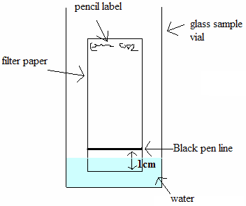
2. Label a piece of filter paper at the top in pencil with the evidence number; 081, and then a separate piece of filter paper with the evidence number 082.
3. Gently draw a horizontal line with the black evidence pen, 081 on the ‘081’ labelled filter paper, 2 cm from the bottom.
4. Do the same with evidence no. 082 on the ‘082’ labelled filter paper.
5. Carefully cut around the dotted pencil line on the envelope with the scissors.
6. Place both filter papers and the piece cut from the envelope upright into the vials, as shown in the diagram.
7. Wait at least 10 minutes and examine the colours.
Questions

1- What has happened on the filter paper?
………………………………………………………………………………………………………………………………………………………………………………………………………………………………………………………………
2- Do the colours produced by evidence 080 (the envelope) match the colours produced by one of the black pens 081 or 082?
……………………………………………………..…………………………………………………………………………………………………………………………………………………………………………………………………………
3- Which pen appears to have been used to write the address on the envelope?
………………………………………………..………………………………………………………………………………………………………………………………………………………………………………………………………………
4- Is the evidence conclusive enough to accuse the owner of the pen?
……………………………………………………………………………………………………………………………………………………………………………………………………………………………………………………………………………………………………………………………………………………

